**City of Vidalia, Georgia**

**Application for Renewals for Alcoholic Beverage License, Occupational Tax and/or COAM**

**PLEASE PRINT OR TYPE ALL INFORMATION DATE: ______________________________________**

**NAME OF BUSINESS: _______________________________________________________________________________________**

**CHECK ONE (1) NEW _______ RENEWAL _______**

# APPLICANT INFORMATION

**(PERSON APPLYING: OWNER, PRESIDENT, CEO, ETC.)**

## NAME: ______________________________________________________________________________________________

**(LAST) (FIRST) (MI)**

**ADDRESS:____________________________________________________________________________________________**

**PHONE: _(W) ______ (H) SS# _______________**

**DATE OF BIRTH: ______________________ DRIVERS LICENSE #: ___________________________________________**

**RESIDENT OF VIDALIA: YES/NO__________** **NUMBER OF YEARS:______________**

**HAVE YOU EVER HAD AN ALCOHOLIC BEVERAGE LICENSE REVOKED? (CITY OR STATE) _______________________________**

**IF YES, EXPLAIN _______________________________________________________________________________________**

**HAVE YOU EVER BEEN CONVICTED OF OR PROSECUTED FOR A CRIMINAL OFFENSE?________________________________**

**IF YES, EXPLAIN ______________________________________________________________________________________**

**DO YOU OWN OR OPERATE ANOTHER ALCOHOLIC BEVERAGE BUSINESS? _______________________________________**

**IF YES, WHERE?______________________________________________________________________________________**

**ARE YOU FAMILIAR WITH THE LOCAL ORDINANCES, REGULATIONS AND STATE LAWS GOVERNING THE POSSESSION AND SALE OF ALCOHOL? _____________________ ARE YOU WILLING TO ABIDE BY THESE?___________________________**

|  |
| --- |
| **DO YOU AGREE FOR OFFICAL INSPECTION OF YOUR BUSINESS WITHOUT A SEARCH WARRANT? ___________________I do hereby authorize the review of, and full.disclosure of all records concerning myself to the duty authorized agent of the City of Vidalia. I understand that any information obtained by personal history background investigation, which is developed directly or indirectly, in whole or part, upon this release authorization will be considered in compiling any report for the City of Vidalia.**  **I certify that any pcrson(s) who may furnish such information concerning me shall not be held accountable for giving this information; and I do hereby release said person(s) from any and all liability, which may be incurred as a result of furnishing such information.**  **A photocopy of this release will be valid as original thereof, even though the said photocopy does not contain an original writing of my signature.**  **APPLICANT'S SIGNATURE DATE** |

**ALL INFORMATION GIVEN WILL BE SUBJECT TO VERIFICATION**

**I UNDERSTAND THAT THE MISREPRESENTATION OR OMISSION OF FACTS CALLED FOR IN THIS APPLICATION ARE GROUNDS FOR A FINE, REVOCATION OF LICENSE, OR BOTH. IF MANAGEMENT CHANGES, I AGREE TO FURNISH CORRECTED INFORMATION TO THE CITY OF VIDALIA WITHIN 10 DAYS. I ALSO UNDERSTAND THAT COMPLETION OF THIS APPLICATION DOES NOT GUARANTEE APPROVAL.**

**APPLICANT'S SIGNATURE ____________________ __________DATE______________NOTARY PUBLIC_______________________DATE________________**

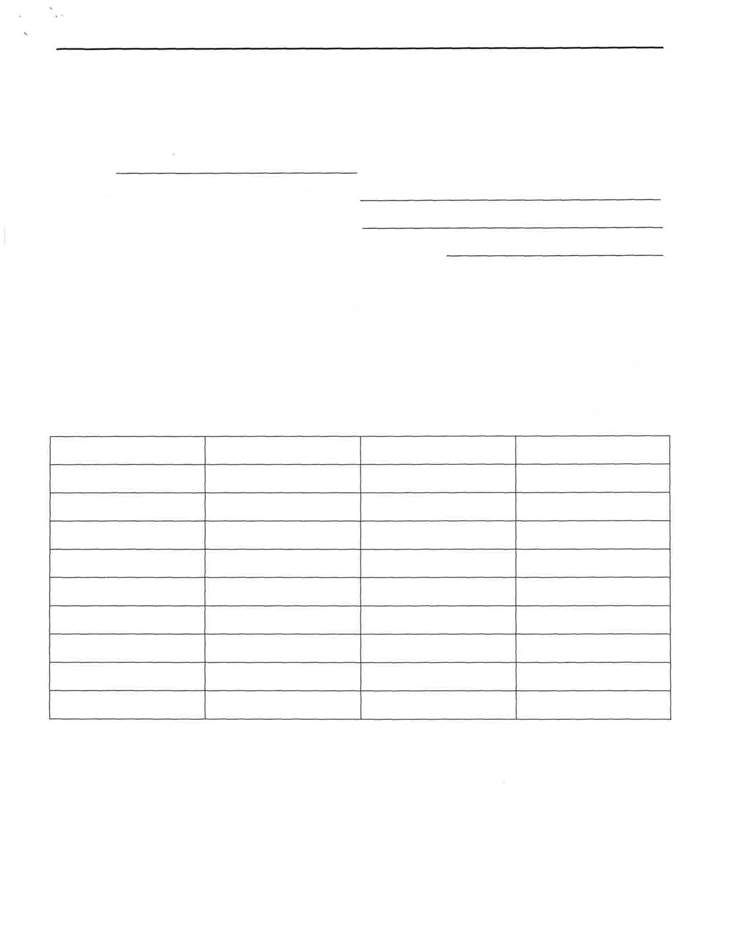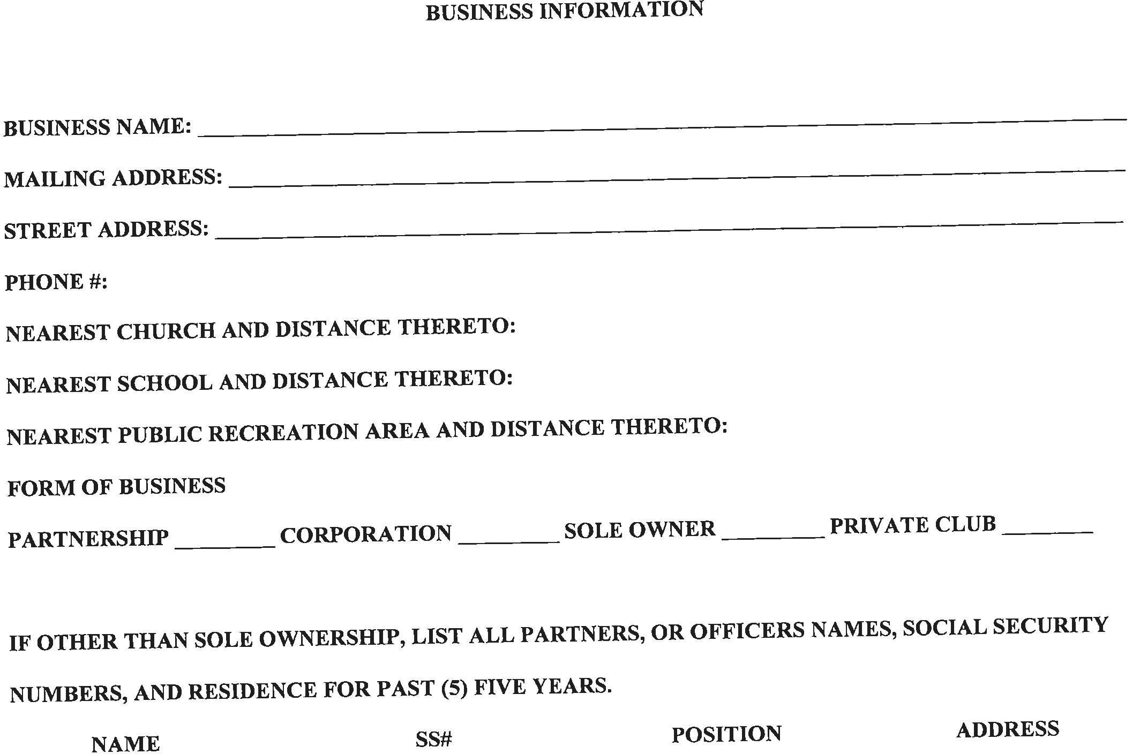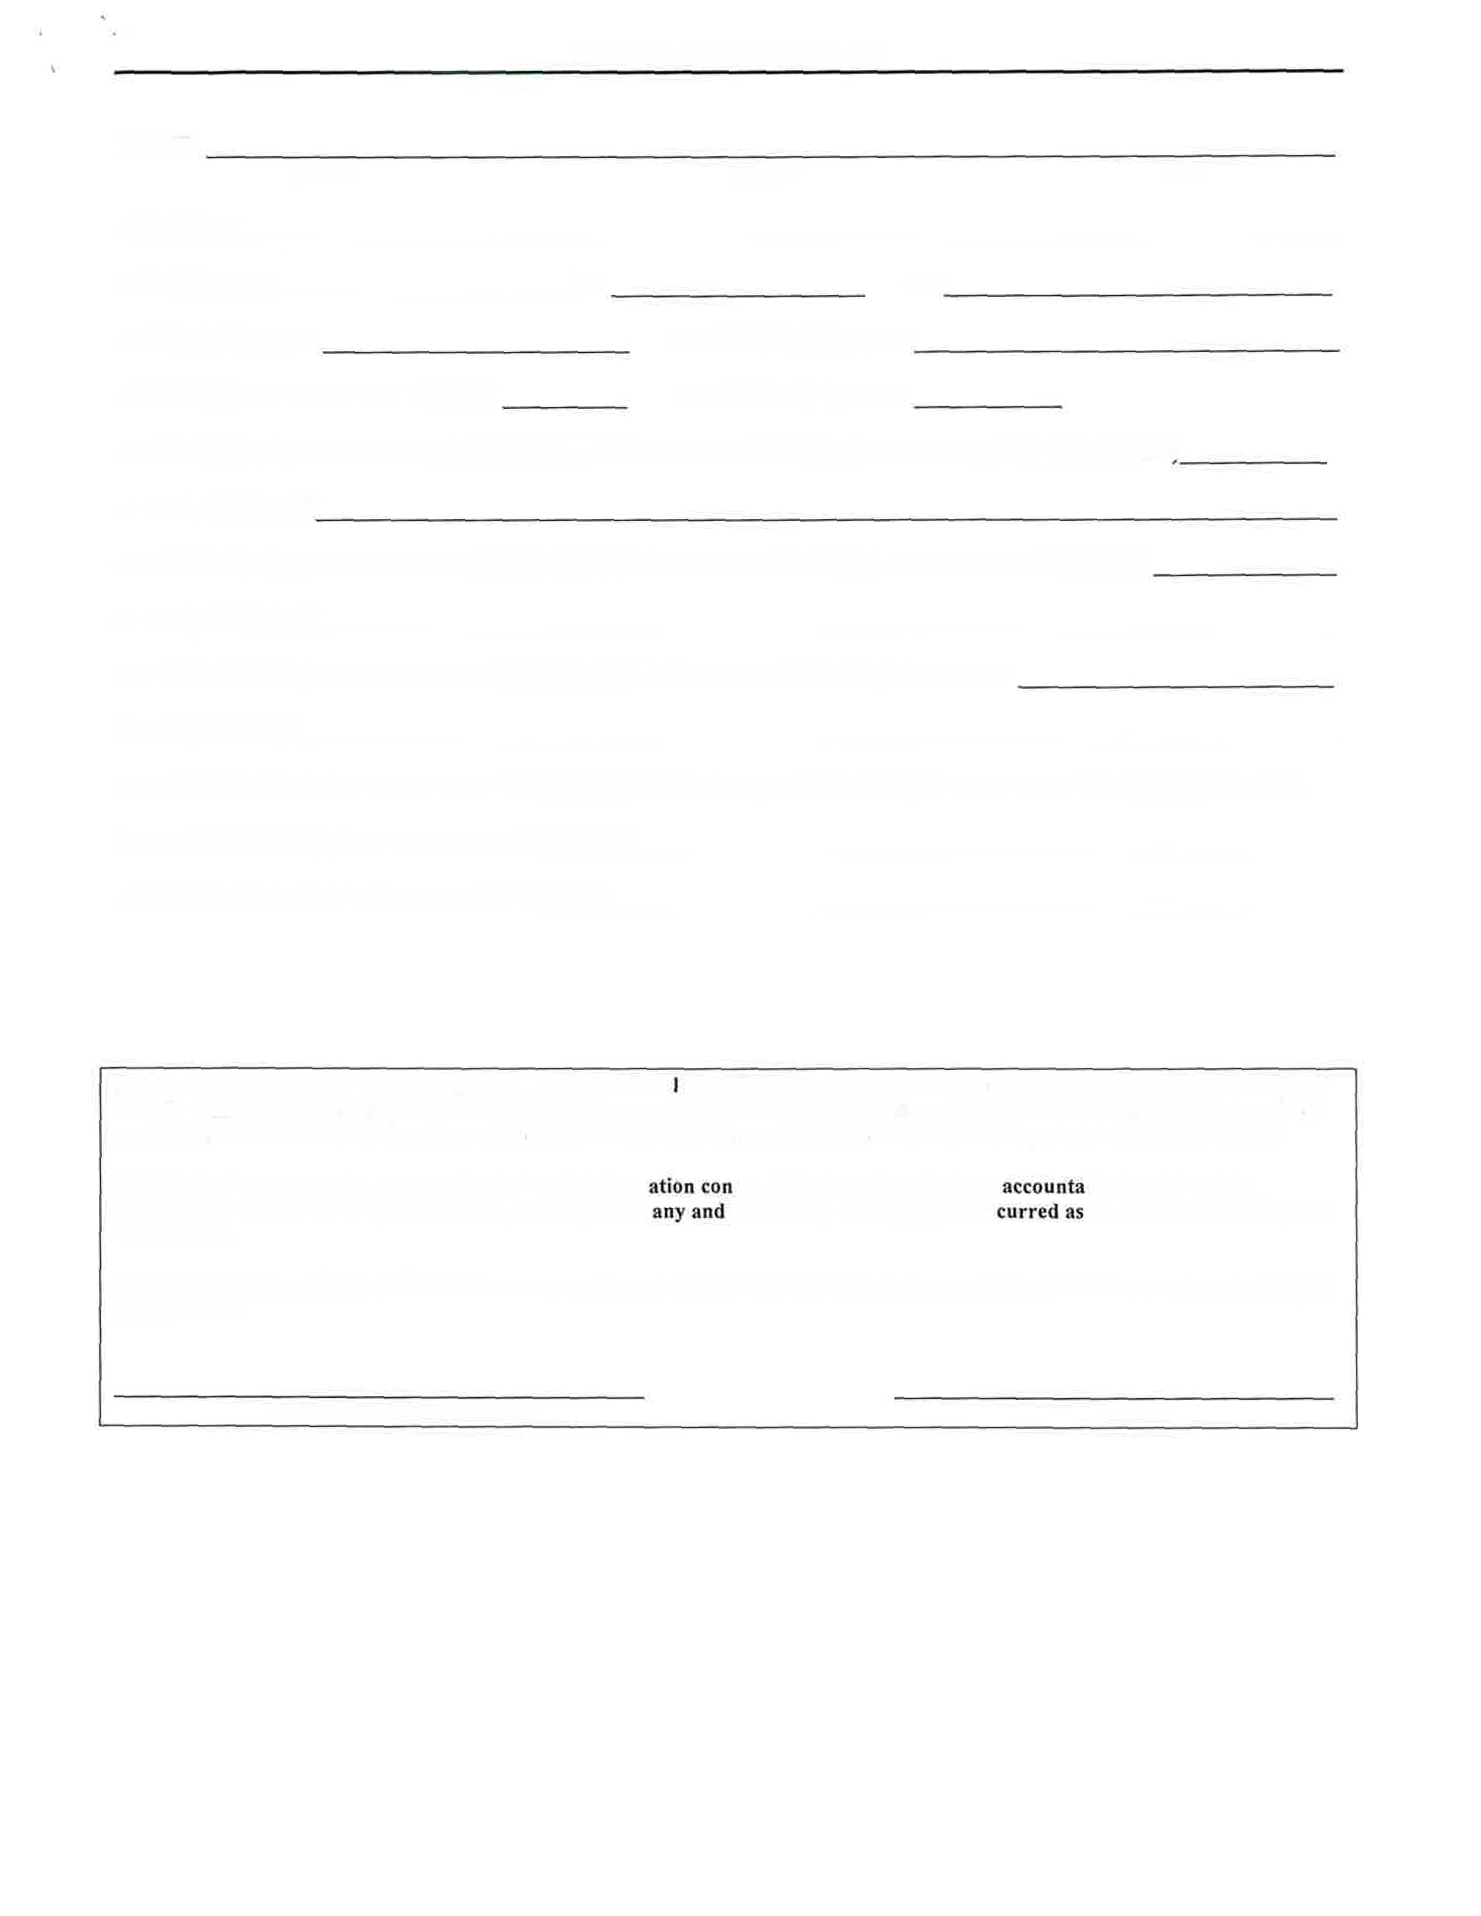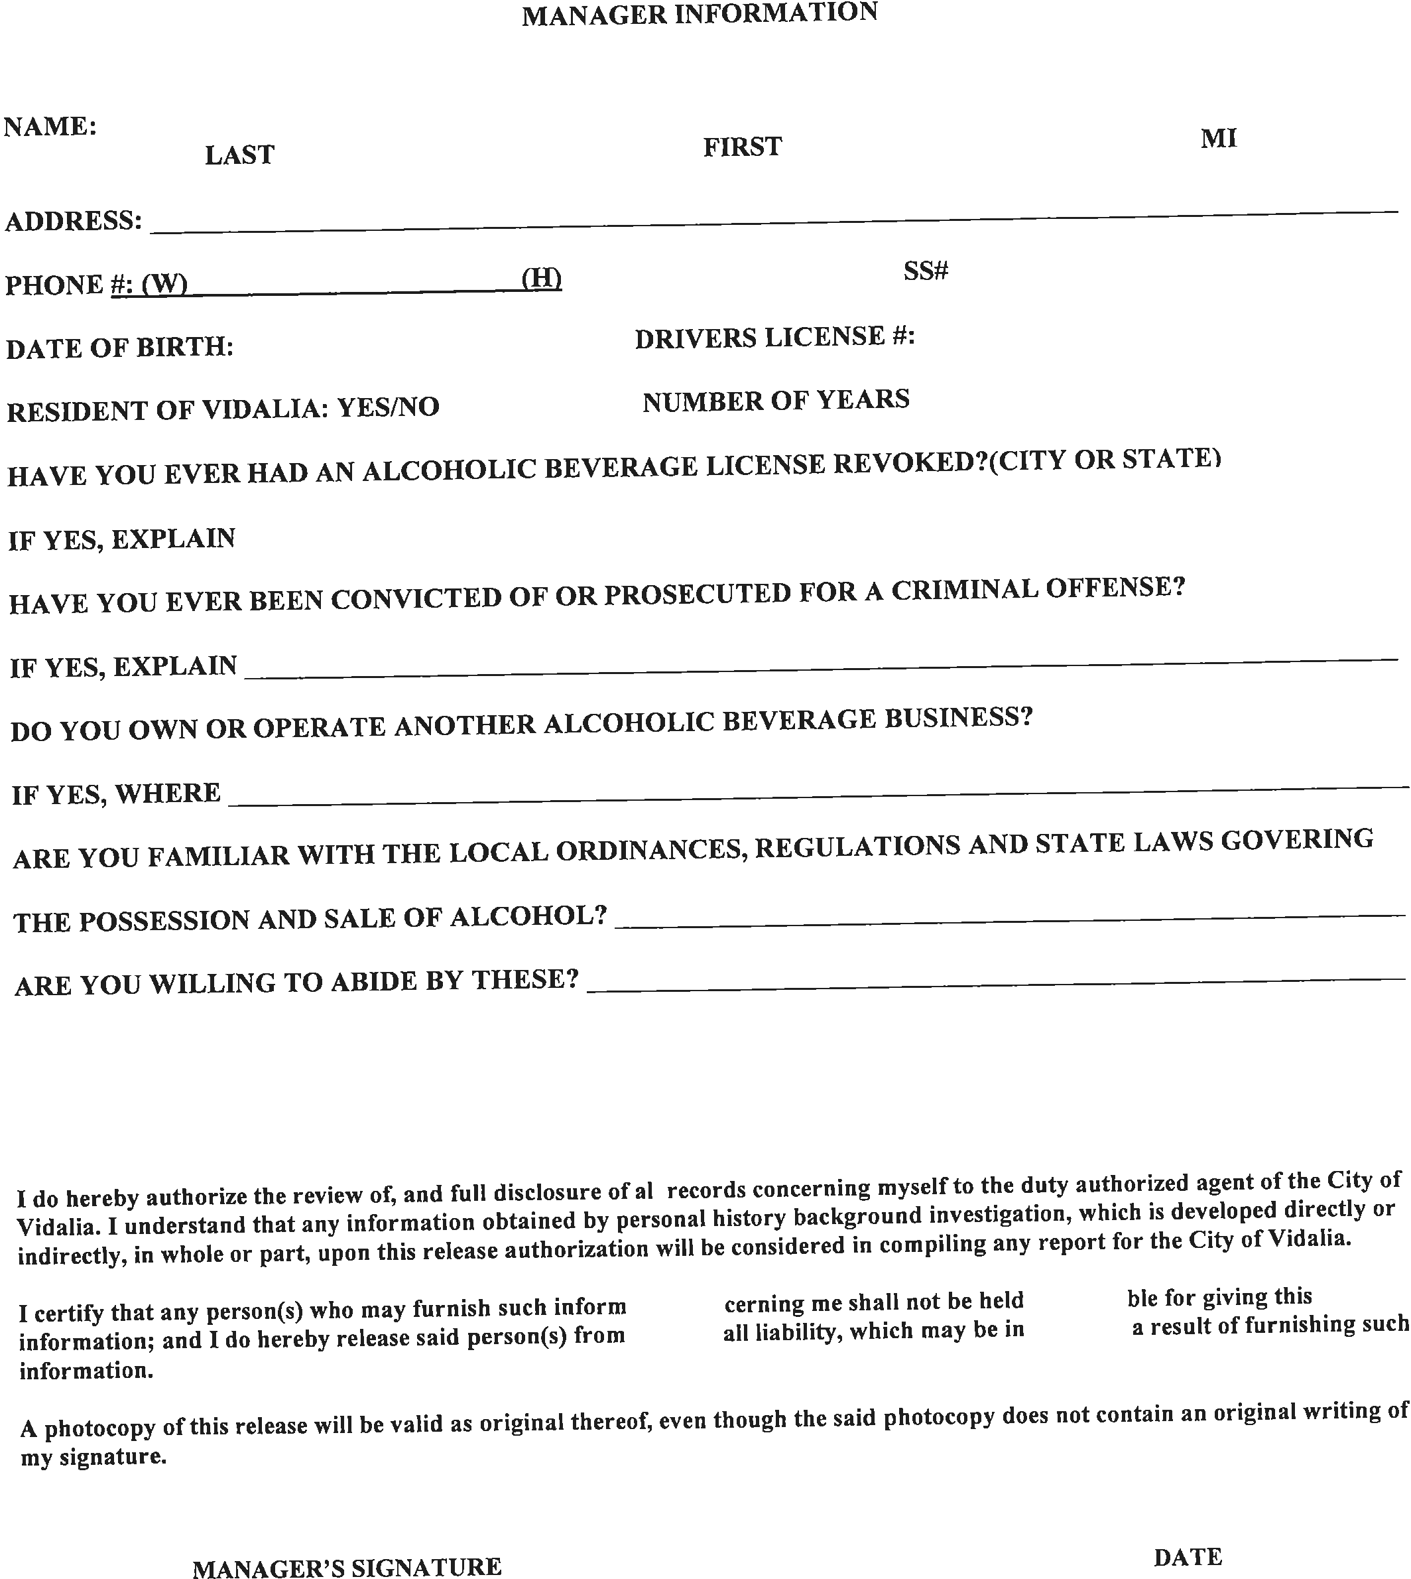

**LICENSE FEE SCHEDULE**

1. **LIQUOR ON PREMISE CONSUMPTION $1500 $_________________**

**(1A) BEER AND WINE ASSOCIATED WITH $300 $_________________**

**ABOVE LICENSE (1)**

**(1B) LIQUOR, BEER, WINE ON PREMISE CONSUMPTION $1150 $_________________**

**(NO SUNDAY SALES ALLOWED)**

1. **BEER AND WINE ON PREMISE CONSUMPTION $600 $_________________**

**(2B) BEER AND WINE ON PREMISE CONSUMPTION $500 $_________________**

**(NO SUNDAY SALES ALLOWED)**

1. **PACKAGED LIQUOR, BEER & WINE $3150 $_________________**
2. **PACKAGED LIQUOR $3000 $_________________**
3. **PACKAGED BEER OR WINE $300 $_________________**
4. **DISTRIBUTOR/WHOLESALER (BEER OR WINE) $350 $_________________**
5. **GROWLER $250 $_________________**
6. **TAPROOM $300 $_________________**
7. **BREWER, MANUFACTURER OF MALT BEVERAGES $1500 $_________________**

**(10) RETAIL LIQUOR, BEER & WINE HOTEL/MOTEL $1800 $_________________**

**IN ROOM MINI BAR SALES ONLY**

**\*\*\*CODE OF ORDINANCES CHAP 2, 4-16(A)* $100 $100**

**TOTAL $_________________**

**\*\*\*OFFICIAL USE ONLY\*\*\***

**POLICE DEPARTMENT _____________________________________________________________**

**(OFFICER) (DATE)**

**FIRE DEPARTMENT________________________________________________________________**

**(INSPECTOR) (DATE)**

**ZONING/BUILDING________________________________________________________________**

**(INSPECTOR) (DATE)**

**MAYOR/COUNCIL_________________________________________________________________**

**(CITY CLERK) (DATE)**

